1. **Create a tentative list of requirements for the proposed system, classifying each as a functional or non-functional requirement.**

Functional Requirements:

1. The system must track the hardware components installed in a client’s equipment
2. The system must track the software configuration information.
3. The system should be able to add software configuration information.
4. The system should be able to set-up clients:

* View the list of components installed in a piece of equipment.
* Add new components to a piece of equipment.
* Install new piece of equipment for a client.

1. The system must have the option to update the list of standard components.
2. The system should have the option to update the list of standard equipment types.
3. The system should support check-in of inventory using barcode.

Non-Functional Requirements:

1. Client information must be entered in the system the same way as it is in the billing system.
2. The system must maintain the list of standard components.
3. The system must be Secure.
4. **Complete a Use-Case Glossary. Make assumptions where necessary.**

|  |  |  |  |  |
| --- | --- | --- | --- | --- |
| Use Case Number | Use-Case Name | Use-Case Description | Assumptions | Participating Actor |
| 1 | Track Hardware Components | The use-case describes the event of potential technician tracking the hardware component. | Assuming that the hardware component exists. | Technician |
| 2 | Track Software Configuration Information | The use-case describes the event of potential technician tracking the software configuration information (free-form information). | Assuming that the software component exists. | Technician |
| 3 | Enter Software Configuration Information | The use-case describes the event of potential technician entering the software configuration information. | None | Technician |
| 4 | View list of components installed | The use-case describes the event of potential bookkeeper or a potential receptionist viewing the list of components installed in a piece of equipment. | Assuming that a default list of components already exists in the system. | Bookkeeper/ Receptionist |
| 5 | Add new components | The use-case describes the event of potential bookkeeper or a potential receptionist adding new components to a piece of equipment. | None | Bookkeeper / Receptionist |
| 6 | Install new piece of equipment | The use-case describes the event of potential bookkeeper or a potential receptionist installing a new piece of equipment for a client. | None | Bookkeeper / Receptionist |
| 7 | Check-in inventory | The use-case describes the event of potential bookkeeper or a potential receptionist performing check-in of the inventory using barcode. | Assuming that barcoding is necessity for check-in of the inventory. | Bookkeeper / Receptionist |
| 8 | Update Standard Components’ list | The use-case describes the event of potential employee updating the list of standard components. | Assuming that the employee can be any staff other than Bookkeeper /Receptionist and Technician. | Employee |
| 9 | Update Standard Equipment Types’ list | The use-case describes the event of potential employee updating the list of standard equipment types. | The employee can be any staff other than Bookkeeper /Receptionist and Technician. | Employee |

1. **Prepare a Use-Case Model Diagram.**

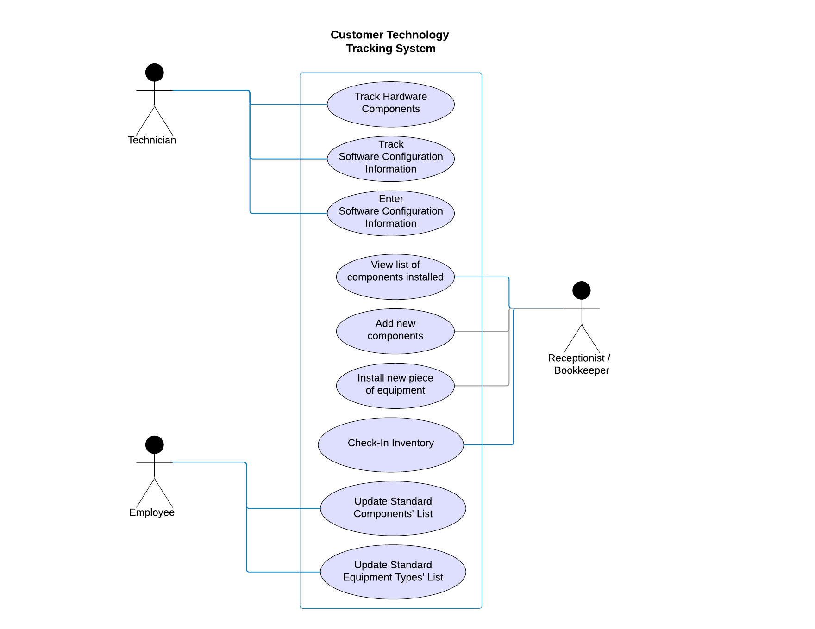

1. **Prepare a fully-documented Use-Case Narrative for the View Components use case described in the interview.**

|  |  |
| --- | --- |
| View Component Use Case | |
| Name | View Component |
| Actor | Receptionist or Bookkeeper |
| Description | The use-case describes the event of potential bookkeeper or a potential receptionist viewing the list of components installed in a piece of equipment. |
| Successful completion: | * The Bookkeeper or Receptionist finds the component list. * The Bookkeeper or Receptionist finds the entry of the component in the component list regarding which a technician or employee requests information. |
| Alternative: | The Bookkeeper or Receptionist does not find the entry of the component in the component list regarding which a technician or employee requests information. |
| Precondition: | A Technician or Employee requests for information which requires the receptionist to view the list of components installed in the equipment. |
| Postcondition: | The Bookkeeper or Receptionist provides the answers to the Technician or Employee after viewing the components. |
| Assumptions: | A component list should exist. |